Abstract: In this paper, the implementation of Hybrid-SLAM (Simultaneous Localization and Mapping) is presented and investigated. Hybrid-SLAM combines the advantage of both EKF and FAST-SLAM to preserve global consistency, reduce the complexity as well as make data association more robust. It has been shown by simulation that linearization and resampling in general leads to over-confidence, which makes loop closure and data association problematic. Combining the particle representation to a Gaussian distribution and incorporating the information into an EKF back-end allows the cross correlation to be remembered over long trajectory as well as minimizing linearization error. By using a sub map approach, the complexity is also reduced compared with pure EKF-SLAM and the number of particles can be reduced compared with FAST-SLAM. In addition, data association becomes more robust as the number of matched features increases significantly.

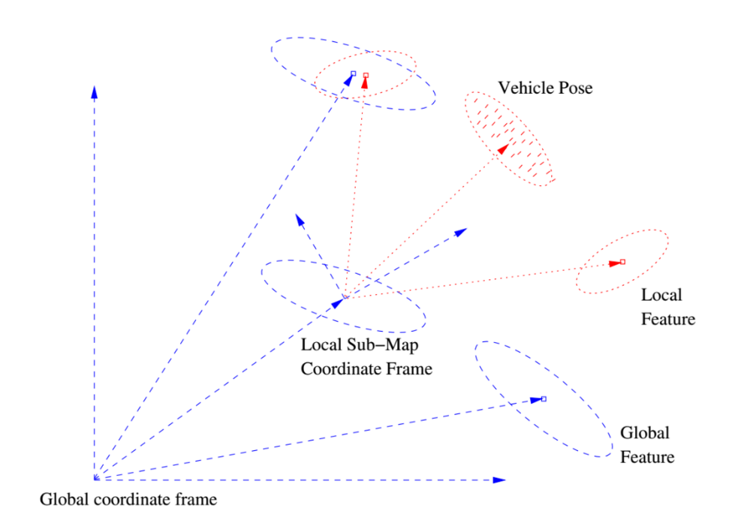

Fig.1 Illustration of the Hybrid-SLAM based on sub map approach

Fig.1 illustrates the idea behind Hybrid-SLAM. A local map is created with its local coordinate frame initialized by the robot pose. After several steps of FAST-SLAM on the local map, the particle representation of the state estimation is transformed to a Gaussian distribution and transformed back to the global coordinate frame. Then the corresponding features are associated with the ones in the global map and updated, and a new local map is created.

Conclusion:

In this paper, the performance of Hybrid-SLAM is evaluated. It has been shown that Hybrid-SLAM outperforms both EKF-SLAM and FAST-SLAM in both loop closure and data association. The reason for that is analyzed in details and the following conclusions can be made:

1. Linearization and resampling in general leads to over-confidence. By combining the particle representation to a Gaussian distribution, the cross correlation between robust and landmarks is allowed to be remembered, which makes it easier to close a large loop.
2. Sub map approach allows the required number of particles in the local map to be reduced and makes JCBB data association more robust as the number of matched features increases.
3. Hybrid-SLAM also inherits to some extent over-confidence from its FAST-SLAM front-end, while the severity is much less than that of FAST-SLAM, which is expected to be addressed by either increasing the number of particles or reducing the steps on the local map before fusion.